WatchMI-Pressure Touch, Twist and Pan Gesture Input on Unmodiﬁed Smartwatches

【Summary】：

We present WatchMI: Watch Movement Input that enhances touch interaction on a smart-watch to support continuous pressure touch, twist, pan gestures and their combinations. Our novel approach relies on software that analyzes, in real-time, the data from a built-in Inertial Measurement Unit (IMU) in order to determine with great ac-curacy and different levels of granularity the actions performed by the user, without requiring additional hardware or modi-fication of the watch.

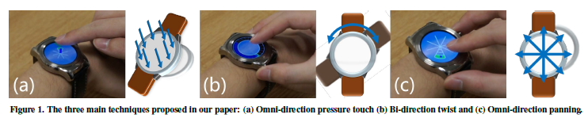

【Apparatus】：

We prototype our system using the Android Wear SDK for an unmodified LG Urbane smartwatch, which mounts an IMU with sensor fusion composed by an Invensense M651 6-axis accelerometer and gyroscope, and by an Asahi Kasei AK8963 3-axis compass sensor.

The IMU senses any changes in acceleration or orien-tation, which can be caused by any hand motion, we use the touch event as a trigger, and stop measuring the value when the user lifts the fingers from the screen. This is simple but very effective: if no touch is detected, the changes in IMU values are discarded, preventing us interpreting accidental motions such as hand waving or gesturing. In addition, we can turn off IMU sensing when it is not necessary, thus reducing battery consumption.

【Experiments】：

**Procedure：**

We designed a user study to assess the usability of the three bespoke input interfaces - pressure, twist and pan input. To characterize the performance of each condition, we modified the three interfaces and collected measures for input entry times and errors (Figure 2). The input for each interface was discretized in 24 selectable regions.

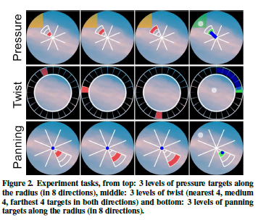

**Discussion：**Discussion and Findings

【Usability analysis】：

To illustrate the potential and immediate feasibility of our ap-proach, we developed 7 applications (Figure 4 and Figure 5) to showcase these 3 interaction techniques - a) Continuous map navigation b) Alarm clock c) Music player d) Pan gesture recognition e) Text entry f) File explorer and g) Controlling remote devices.

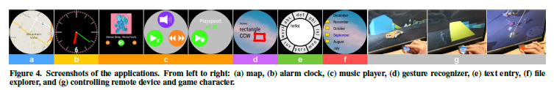

【Conclusion】：

In this work, we designed and implemented three techniques for augmenting normal touch input on a smartwatch, which lead to many potential use cases. Our techniques use only the signal from integrated IMU to infer the action and its magni-tude. Thus, it can already work on most of the smartwatch in the market, perhaps via a simple software update. Our user study showed that our techniques are immediately feasible, with users’ input accuracies in excess of 98.4%.

【Important Reference】:

14. Masa Ogata and Michita Imai. 2015. SkinWatch: Skin Gesture Interaction for Smart Watch. In Proceedings of the 6th Augmented Human International Conference (AH ’15). ACM, New York, NY, USA, 21–24. DOI: http://dx.doi.org/10.1145/2735711.2735830

15. Simon T. Perrault, Eric Lecolinet, James Eagan, and Yves Guiard. 2013. Watchit: Simple Gestures and Eyes-free Interaction for Wristwatches and Bracelets. In Proceedings of the SIGCHI Conference on Human Factors in Computing Systems (CHI ’13). ACM, New York, NY, USA, 1451–1460. DOI: http://dx.doi.org/10.1145/2470654.2466192

16. Jun Rekimoto and Carsten Schwesig. 2006. PreSenseII: Bi-directional Touch and Pressure Sensing Interactions with Tactile Feedback. In CHI ’06 Extended Abstracts on Human Factors in Computing Systems (CHI EA ’06). ACM, New York, NY, USA, 1253–1258. DOI: http://dx.doi.org/10.1145/1125451.1125685

4. Liwei Chan, Rong-Hao Liang, Ming-Chang Tsai,

Kai-Yin Cheng, Chao-Huai Su, Mike Y. Chen,

Wen-Huang Cheng, and Bing-Yu Chen. 2013. FingerPad: Private and Subtle Interaction Using Fingertips. In Proceedings of the 26th Annual ACM Symposium on User Interface Software and Technology (UIST ’13). ACM, New York, NY, USA, 255–260. DOI: http://dx.doi.org/10.1145/2501988.2502016

7. Chris Harrison and Scott E. Hudson. 2009. Abracadabra: Wireless, High-precision, and Unpowered Finger Input for Very Small Mobile Devices. In Proceedings of the 22Nd Annual ACM Symposium on User Interface Software and Technology (UIST ’09). ACM, New York, NY, USA, 121–124. DOI: http://dx.doi.org/10.1145/1622176.1622199

20. Anusha Withana, Roshan Peiris, Nipuna Samarasekara, and Suranga Nanayakkara. 2015. zSense: Enabling Shallow Depth Gesture Recognition for Greater Input Expressivity on Smart Wearables. In Proceedings of the 33rd Annual ACM Conference on Human Factors in Computing Systems (CHI ’15). ACM, New York, NY, USA, 3661–3670. DOI: http://dx.doi.org/10.1145/2702123.2702371

22. Haijun Xia, Tovi Grossman, and George Fitzmaurice. 2015. NanoStylus: Enhancing Input on Ultra-Small Displays with a Finger-Mounted Stylus. In Proceedings of the 28th Annual ACM Symposium on User Interface Software &#38; Technology (UIST ’15). ACM, New York, NY, USA, 447–456. DOI: http://dx.doi.org/10.1145/2807442.2807500

Robert Xiao, Julia Schwarz, and Chris Harrison. 2015. Estimating 3D Finger Angle on Commodity Touchscreens. In Proceedings of the 2015 International Conference on Interactive Tabletops & Surfaces (ITS ’15). ACM, New York, NY, USA, 47–50. DOI: http://dx.doi.org/10.1145/2817721.2817737